Istio API Gateway Service Mesh Project
Minikube was not up and running fully. It was shutdown before due to which Kubectl was misconfigured to use minikube. Kubeconfig was not refreshed with recent changes.For that run minikube stop and then minikube start –driver=docker. This command updated kubeconfig with the correct API server address. minikube start will update the address book with the new API server location.
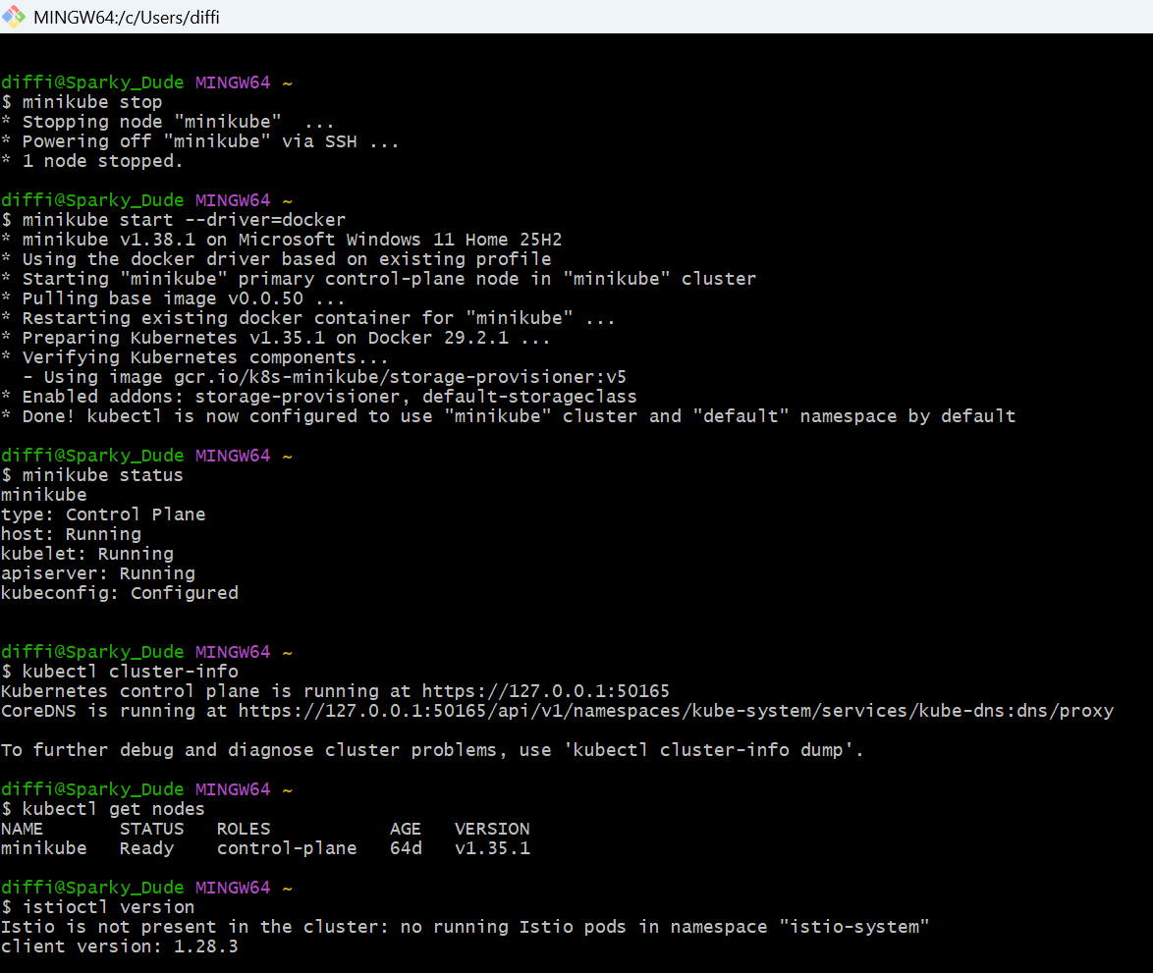
Verified Docker is running and Istio CLI. For now, Istio is ready to be installed.
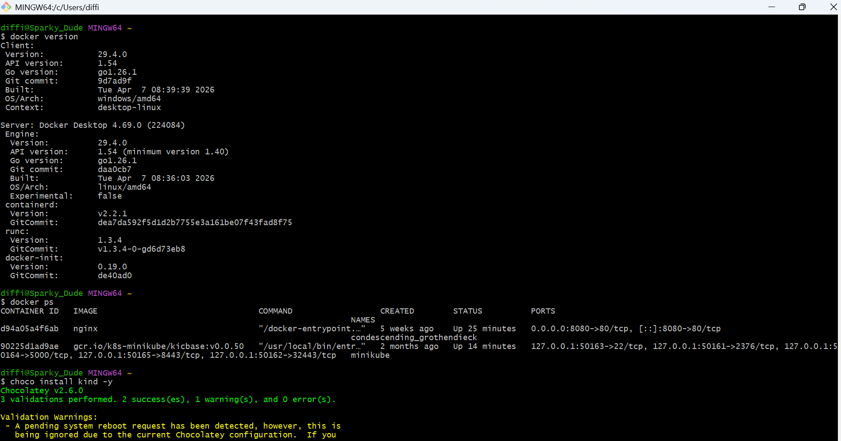
Think of Kubernetes as a hotel:
- kubectl is the receptionist who knows where the hotel is.
- The Kubernetes API server is the hotel address.
- ~/.kube/config is the address book.
Installing Kind: I am using Kind (Kubernetes IN Docker) for Istio API Gateway project. It creates Kubernetes clusters as Docker containers and is lightweight. I have installed kind using chocolatey package using ‘choco install kind -y’ command.

Creating first Kubernetes Cluster:-
kind create cluster --name dev. New container named ‘dev-control-plane’ is the Kubernetes node.
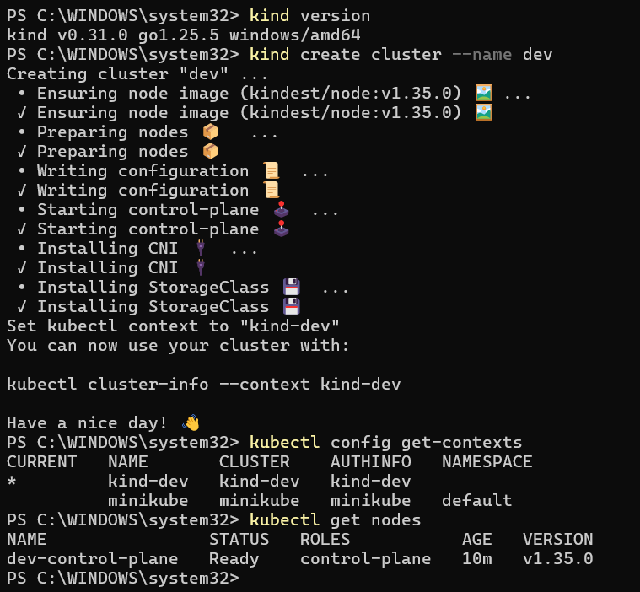

Kind vs Minikube (for your project)
Since your MCA final project is "Implementation of API Gateway using Istio Service Mesh", I would actually recommend Kind.
Feature | Minikube | Kind
Uses Docker | Yes | Yes
Lightweight | Good | Excellent
Cluster creation speed | Slower | Faster
CI/CD usage | Less common | Very common
Multi-node clusters | Possible | Very easy
Works well with Istio | Yes | Yes
Good for learning K8s | Yes | Yes

Roadmap for my project:

Docker Desktop
|
|
Kind Cluster
|
Kubernetes
|
Istio Service Mesh
|
Istio Ingress Gateway
|
Microservices
(Frontend + Backend + DB)

My Kubernetes environment (fully working Kubernetes cluster running inside Docker Desktop.)
Kind Version : v0.31.0
Cluster Name : dev
Kubernetes Version: v1.35.0
Context : kind-dev
Node : dev-control-plane
Status : Ready
Created another kind cluster:
kind create cluster --name istio-api-gateway --config .\kind\cluster.yaml
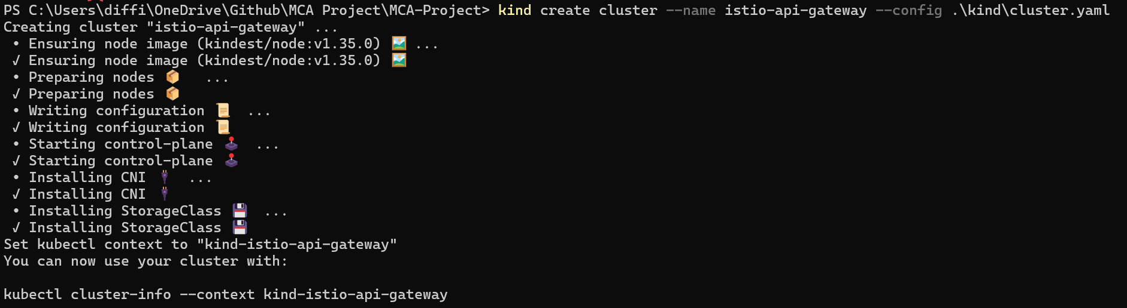
Install Istio: Below screenshot shows
✔ Istio core installed
✔ Istiod installed
✔ Egress gateways installed
✔ Ingress gateways installed
✔ Installation complete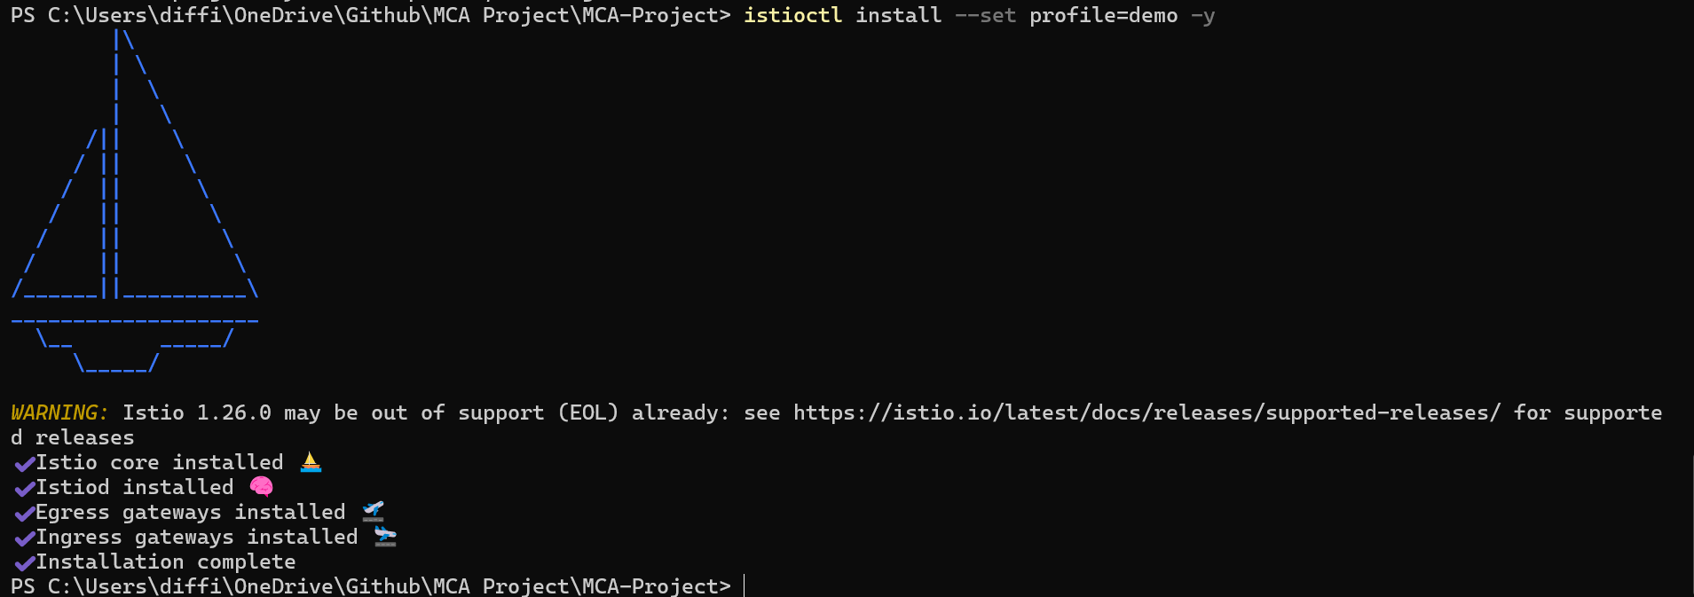
My architecture evolved to
Kind Cluster
|
----------------------
| |
Kubernetes API Istio System
|
+-----------+
| istiod |
+-----------+
|
Istio Ingress Gateway
|
Your Services
Build and load service images using below commands
docker build -t customer-service:local .\services\customer-service
docker build -t order-service:local .\services\order-service
docker build -t payment-service:local .\services\payment-service
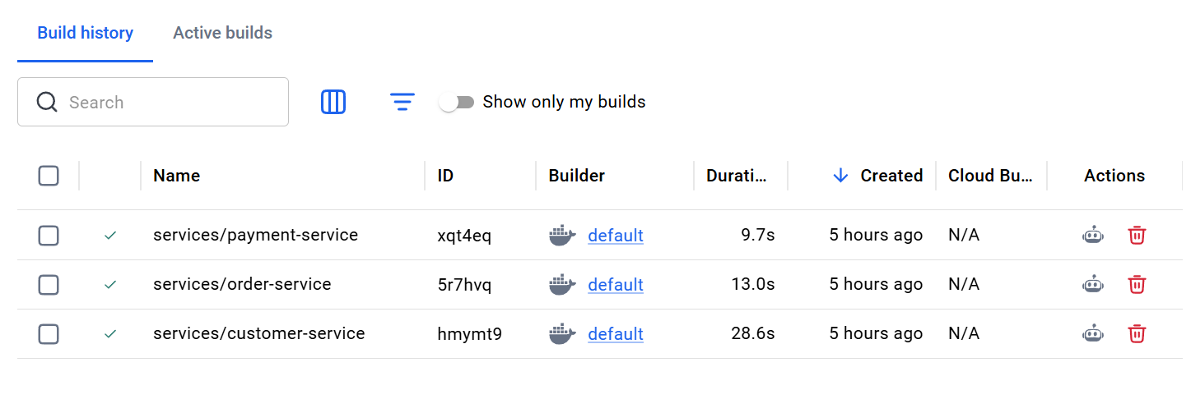
kind load docker-image customer-service:local --name istio-api-gateway
kind load docker-image order-service:local --name istio-api-gateway
kind load docker-image payment-service:local --name istio-api-gateway

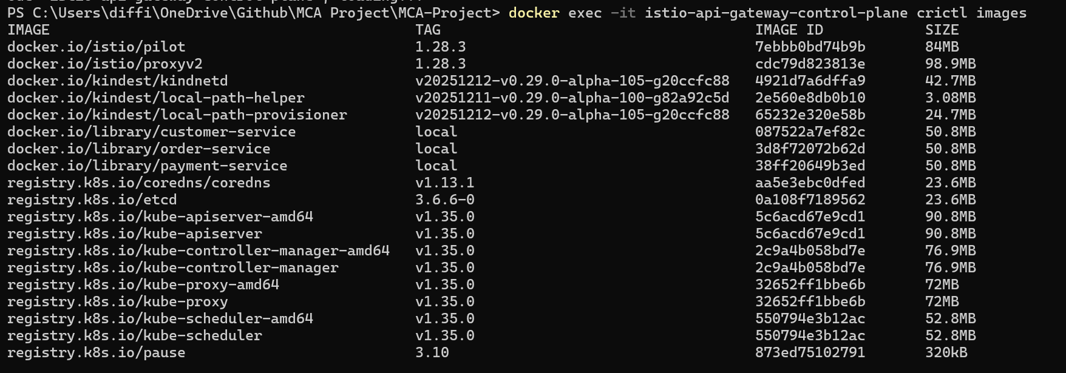

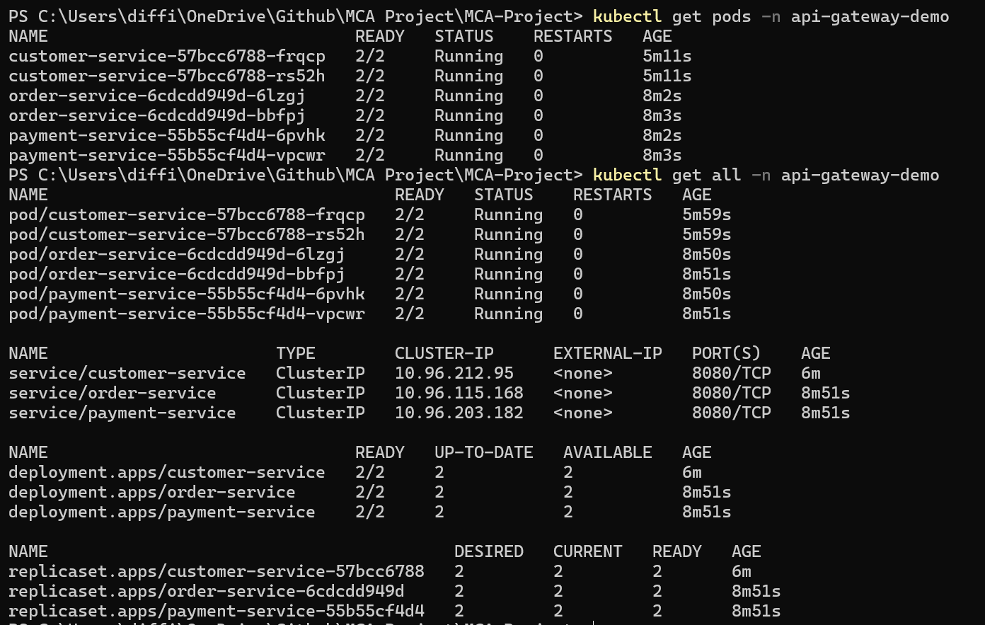
This tells us a very important thing:
- 2 containers exist inside each Pod
  - Your application container
  - Istio Envoy sidecar (istio-proxy)
Example:-
customer-service Pod
│
├── customer-service container
│ └── Your Python/Node/Java application
│
└── istio-proxy container
└── Envoy proxy managed by Istio

Services also created
customer-service ClusterIP 10.96.212.95:8080
order-service ClusterIP 10.96.115.168:8080
payment-service ClusterIP 10.96.203.182:8080

A ClusterIP means:
- Accessible only inside the Kubernetes cluster
- Other pods can communicate using DNS names
For example:
http://customer-service:8080
http://order-service:8080
http://payment-service:8080
Kubernetes DNS automatically resolves these names.
We have reached this stage: Currently, applications are only reachable inside the cluster.
Kind Cluster
|
Kubernetes
|
+------------+------------+
| | |
v v v
customer order-service payment-service
Pod Pod Pod
| | |
Envoy Proxy Envoy Proxy Envoy Proxy

❌ Not accessible from browser yet
The next big step: Istio API Gateway 🚪
Now we will expose all services through one entry point.
Browser
|
localhost:80
|
Istio Ingress Gateway
|
+-------+-------+
| |
/customer /order
| |
customer-service order-service

/payment
|
payment-service
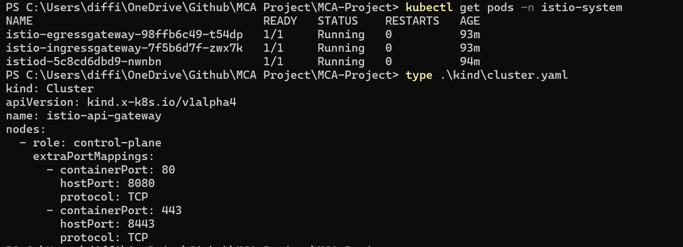
Above image shows environment is 100% ready for the Istio API Gateway implementation.

My k8s/istio directory contains:
k8s/istio/
│
├── gateway.yaml
├── virtual-service.yaml
├── destination-rules.yaml
└── security.yaml
Below explanation is given for each files.
1. gateway.yaml 🚪
Purpose: Exposes your application to the outside world.
Flow:
Browser
|
localhost:8080
|
Istio Ingress Gateway
It defines:
- Which ports to listen on (80/443)
- HTTP or HTTPS
- Allowed hosts
Example:
kind: Gateway

2. virtual-service.yaml 🧭
Purpose: Traffic routing rules.
Example:
Request:
localhost:8080/customer
|
↓
customer-service
It tells Istio:
/customer → customer-service
/order → order-service
/payment → payment-service
Example:
kind: VirtualService

3. destination-rules.yaml ⚙️
Purpose: Defines policies after traffic reaches a service.
Example:
VirtualService
|
↓
DestinationRule
|
↓
customer-service
It controls:
- Load balancing algorithms
- Connection pools
- Circuit breakers
- TLS settings
- Service subsets (v1/v2 deployments)
Example:
kind: DestinationRule

4. security.yaml 🔐
Purpose: Istio security policies.
Usually contains:
- PeerAuthentication for mTLS
- AuthorizationPolicy for access control
- RequestAuthentication for JWT validation
Example:
kind: PeerAuthentication
This is a great addition for your MCA project because you can discuss zero-trust networking in your viva.
The below image shows istio configuration being deployed.
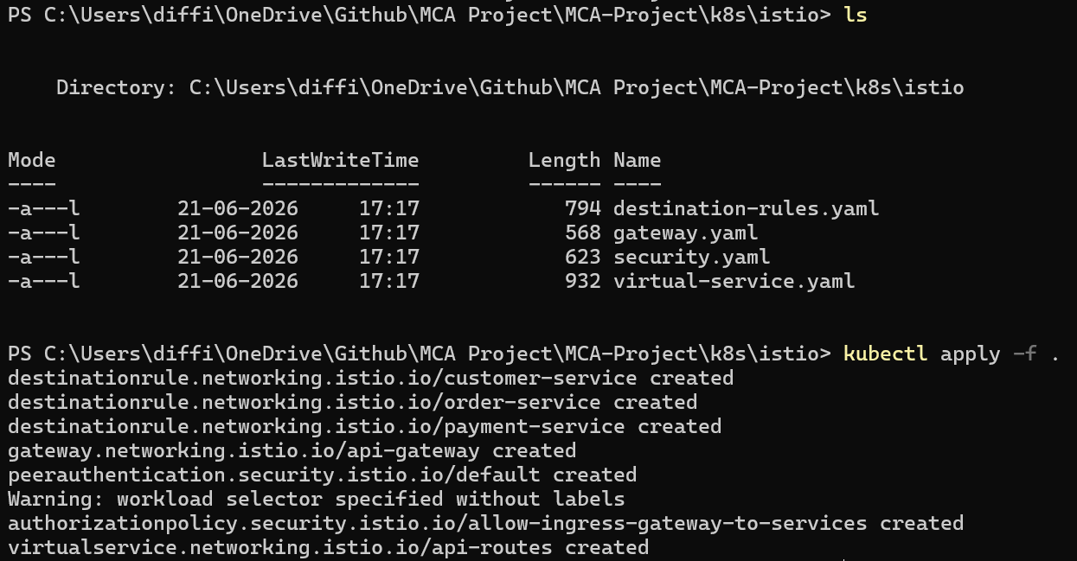
Let us verify if deployment was successful:-
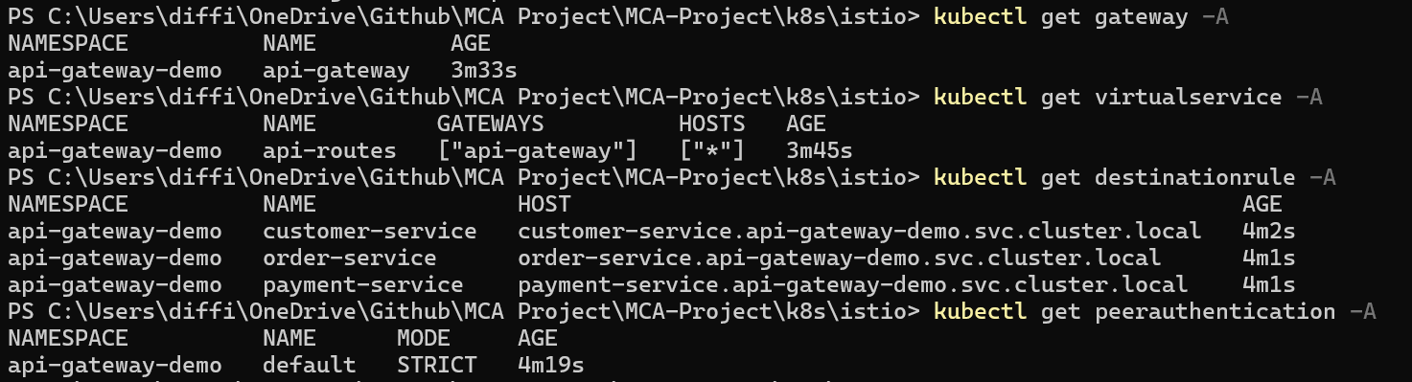
Before we test from the browser, I will ensure if my Gateway is using the Istio ingress gateway selector by running command ‘type .\gateway.yaml’
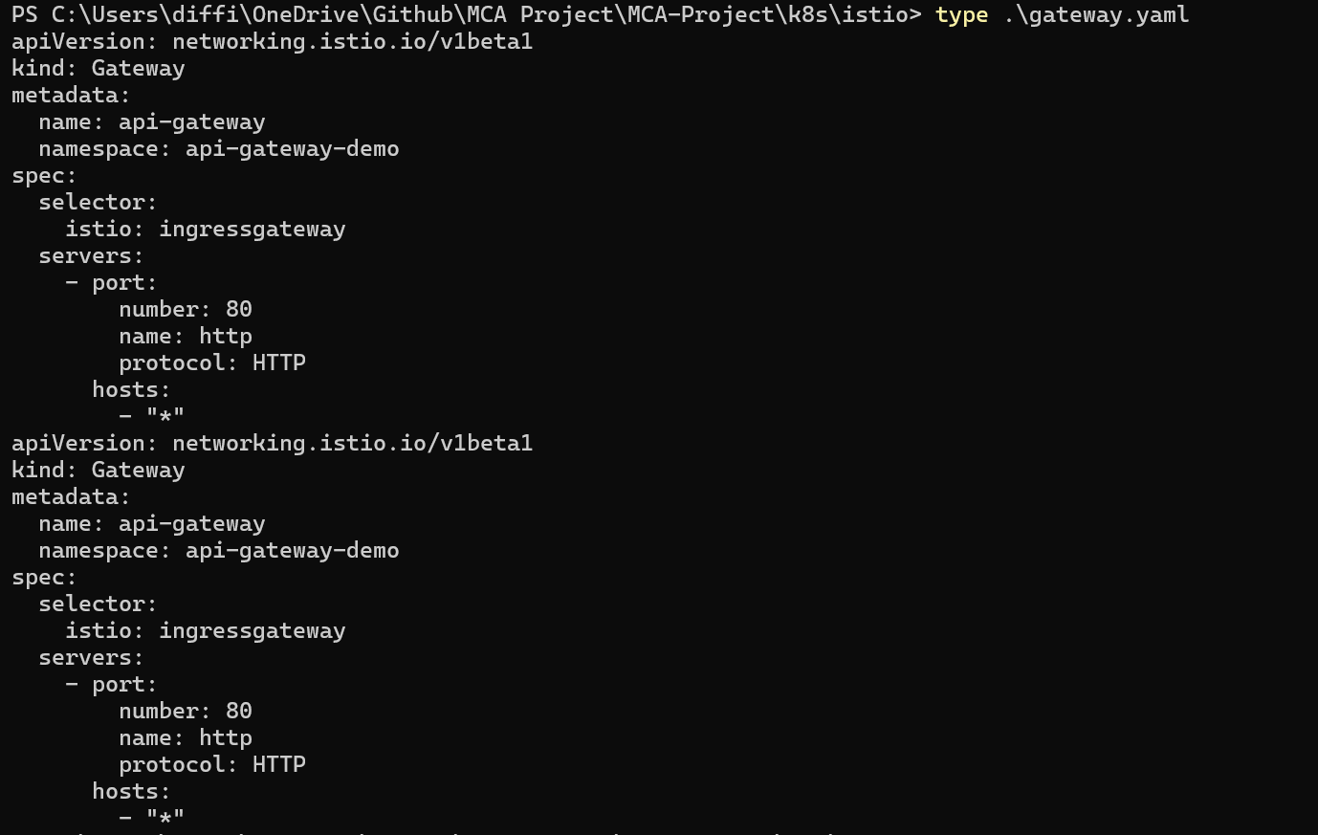
verified the Istio ingress service.
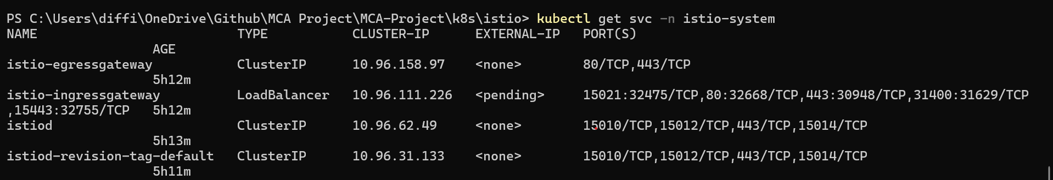

Below are the URLs to browse
http://localhost:8080/api/orders
http://localhost:8080/api/customers
http://localhost:8080/api/payments

